Assignment-3:- Hypothesis Testing Exercise
1. A F&B manager wants to determine whether there is any significant difference in the diameter of the cutlet between two units. A randomly selected sample of cutlets was collected from both units and measured? Analyze the data and draw inferences at 5% significance level. Please state the assumptions and tests that you carried out to check validity of the assumptions.
Minitab File: Cutlets.mtw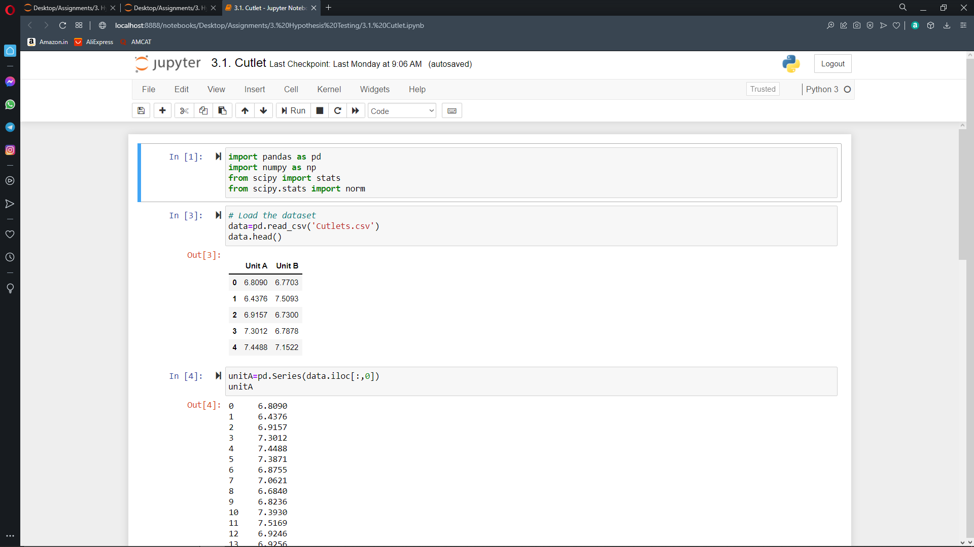
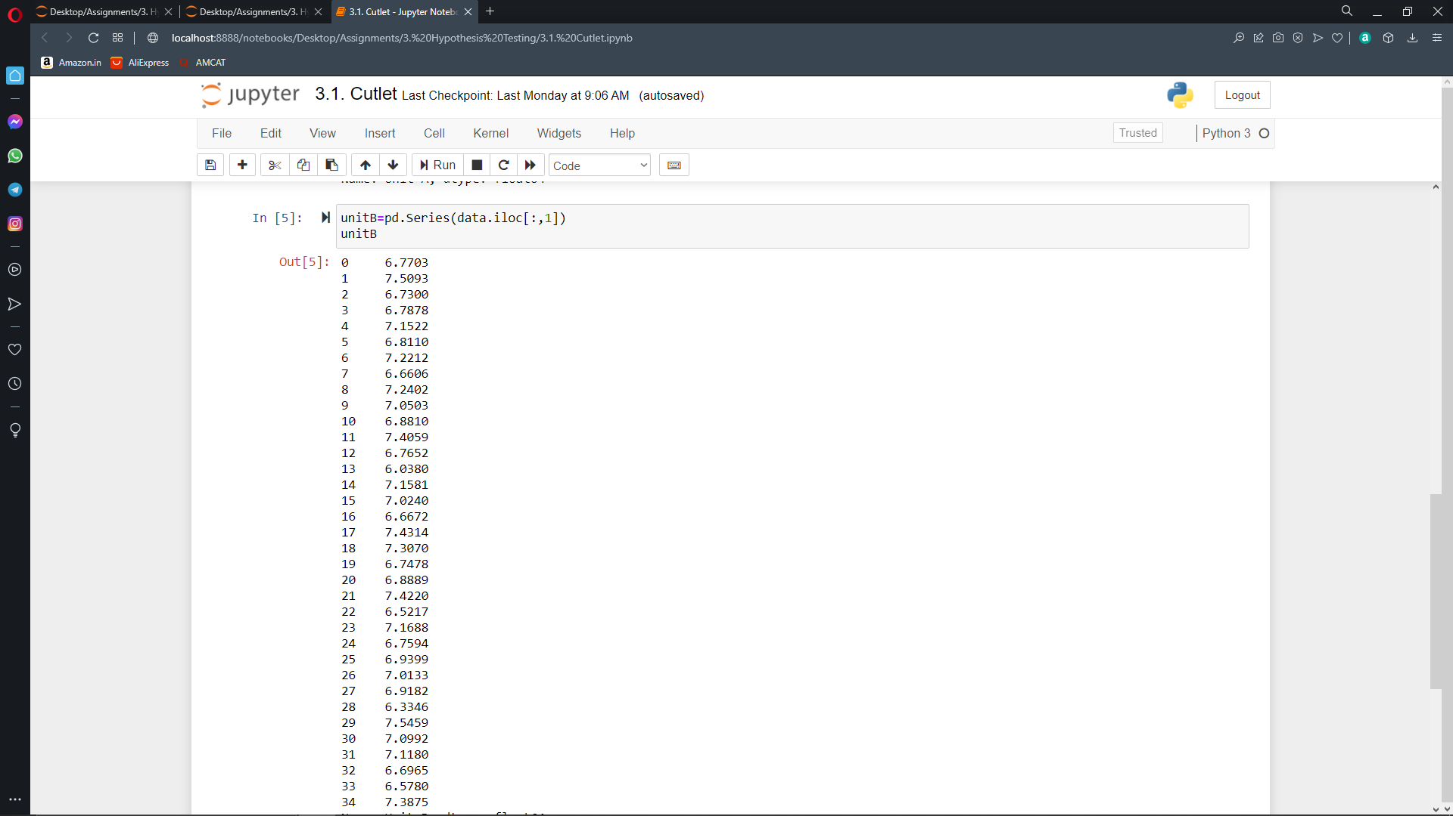

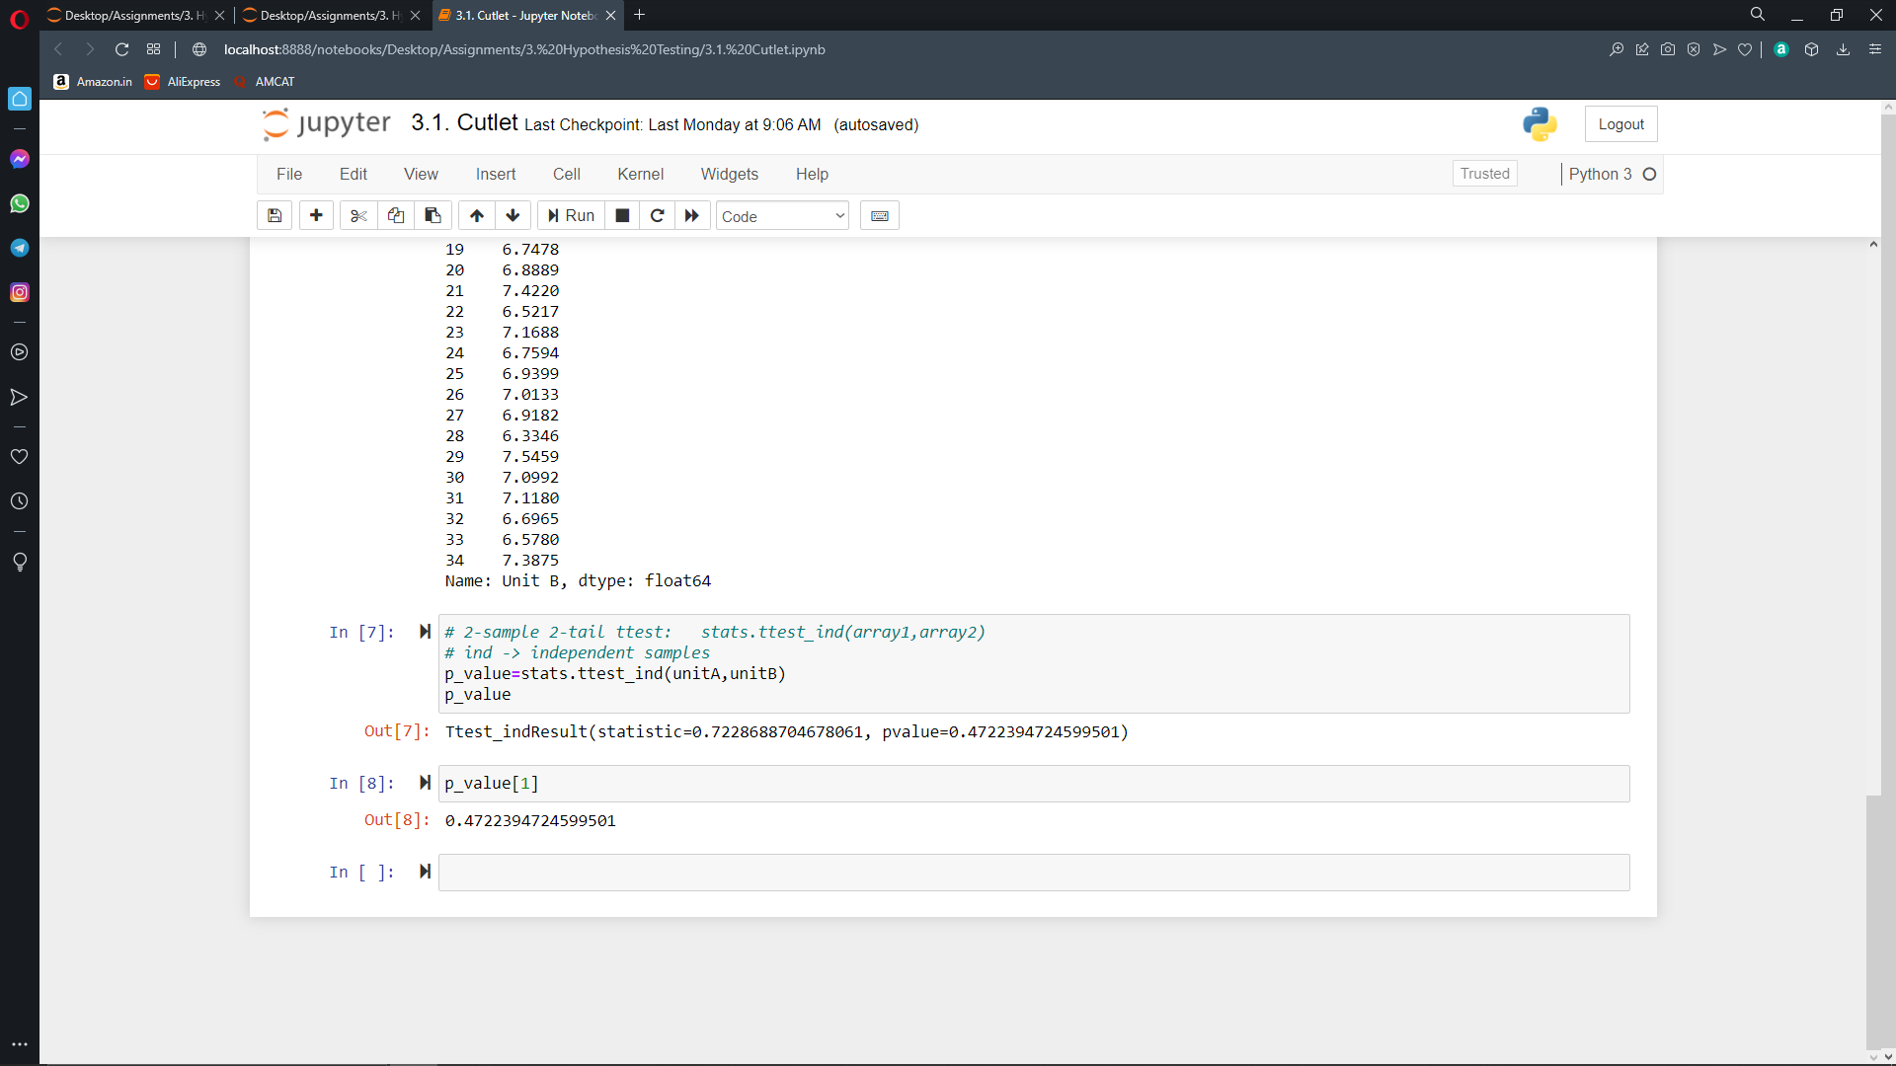
2. A hospital wants to determine whether there is any difference in the average Turnaround Time (TAT) of reports of the laboratories on their preferred list. They collected a random sample and recorded TAT for reports of 4 laboratories. TAT is defined as sample collected to report dispatch. Analyze the data and determine whether there is any difference in average TAT among the different laboratories at 5% significance level.
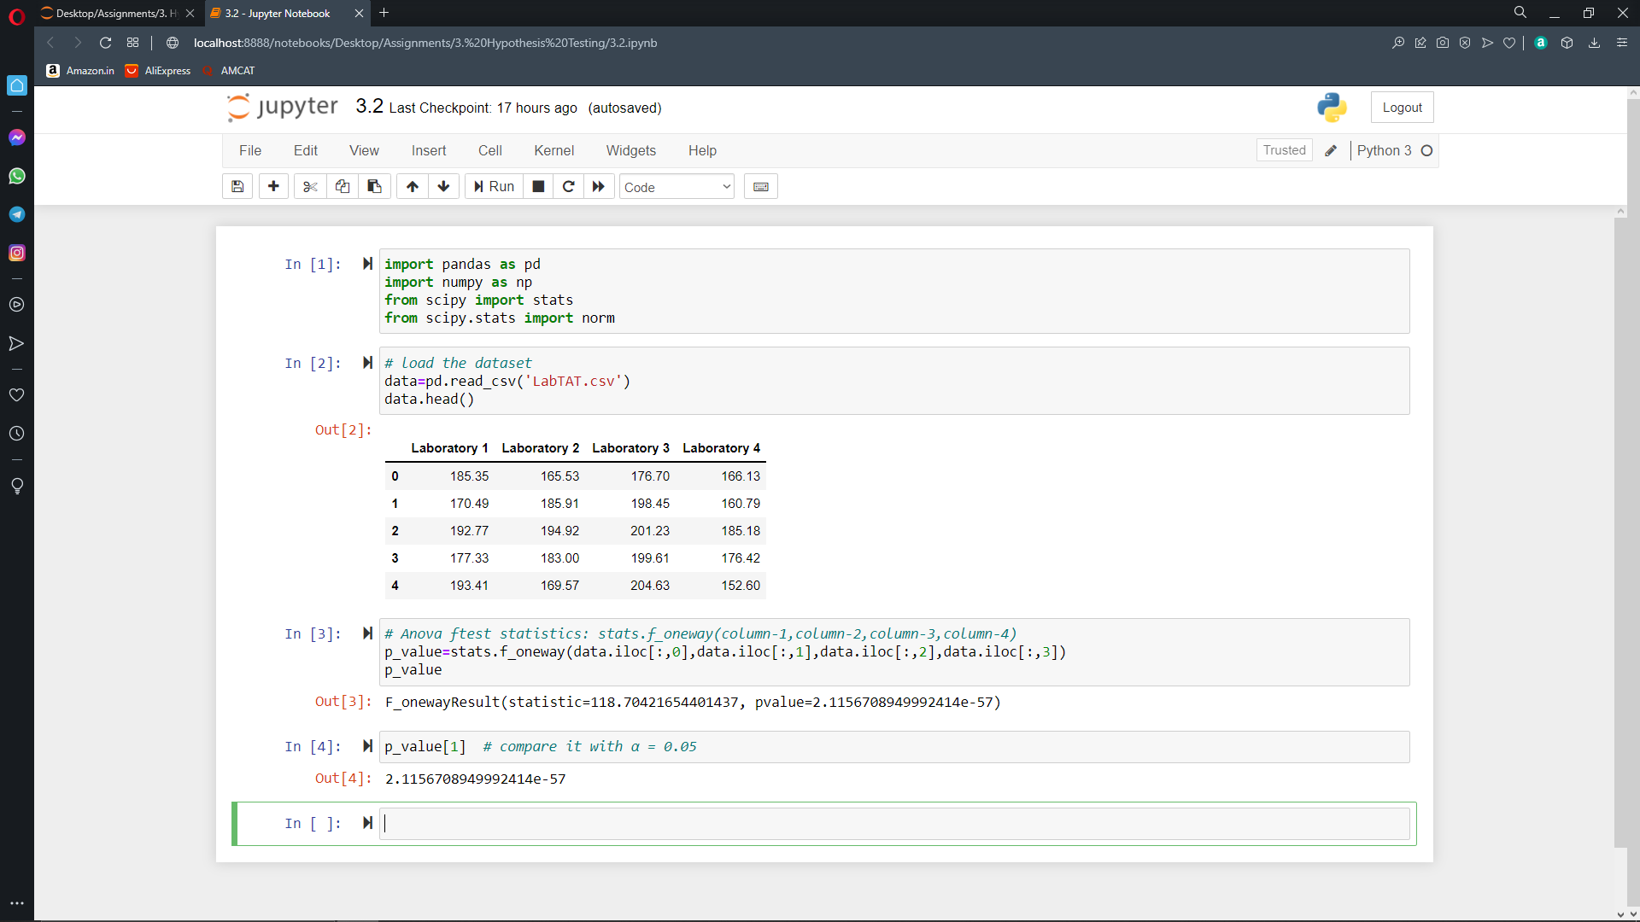
3.

